LifeRx.md Teams Up with TV Personality Emily Simpson to Expand Licensed-Provider Wellness Offerings
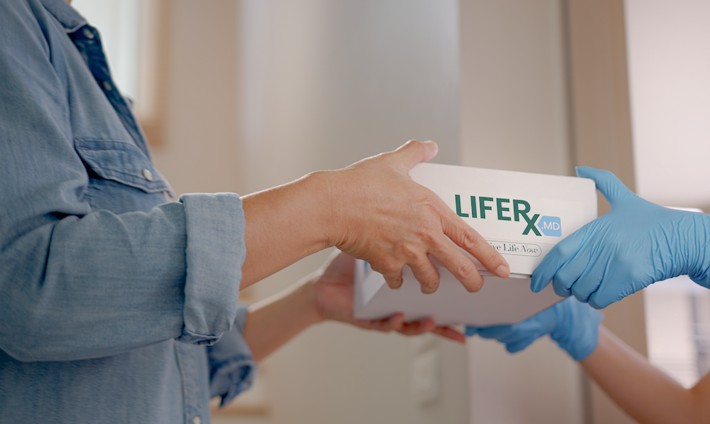
Las Vegas, NV – October 29, 2025 – LifeRx.md, a leading telehealth platform specializing in provider-supervised metabolic and cellular health care, announces a new collaboration with television personality and wellness advocate Emily Simpson. This partnership continues LifeRx.md’s mission to make high-quality, personalized wellness support more accessible to individuals nationwide.
As part of this collaboration, Emily Simpson will serve as a public-facing ambassador for LifeRx.md’s consumer-direct programs. By combining her wellness journey and public platform with LifeRx.md’s licensed-provider care model, the partnership aims to spotlight how personalized telehealth can integrate into real-life routines. Together, they will participate in content campaigns and wellness-focused initiatives designed to engage consumers seeking reliable and flexible options for their health goals.
LifeRx.md delivers care through Licensed U.S. providers and recently expanded its offerings to include NAD⁺ protocols and cellular wellness support. These additions further strengthen the company’s position in the metabolic and performance-optimization space.
The brand’s previous collaborations with public figures—including Margaret Josephs, who has highlighted her experience with GLP-1-based care, and a men's health initiative with Mario Lopez—have helped normalize modern wellness solutions delivered via telehealth. Emily Simpson now brings a new voice to the conversation, particularly among women navigating practical health needs and time-limited lifestyles.
New Program Highlights
- LifeRx.md and Simpson will introduce a co-branded wellness track focused on personalized intake, ongoing provider interaction, and remote monitoring.
- Key areas will include metabolic wellness, hormone support, GLP-1 treatment options, and regenerative health protocols such as NAD⁺.
- The program emphasizes accessible care, flexible plan adjustments, and clear pricing—with no insurance required or long-term commitments.
- A multimedia campaign featuring Simpson’s experience will help expand public understanding of responsible, provider-led telehealth.
Strengthening Market Impact
“With this collaboration, we’re continuing our commitment to empowering individuals to take control of their wellness through modern, evidence-based care,” said Nic Sementas, Chief Advocacy Officer at LifeRx.md. “Emily Simpson’s story adds authenticity and relatability to what we offer—support that’s adaptable, clinically grounded, and designed for everyday life.”
LifeRx.md’s focus on metabolic, hormonal, and cellular health continues to set it apart in the wellness space, with licensed U.S. providers delivering individualized care through a secure, virtual-first model.
About LifeRx.md
LifeRx.md is a telehealth and wellness platform focused on metabolic, hormonal, and cellular health. All treatments are prescribed by licensed U.S. providers based on individual consultations, with personalized care plans, ongoing monitoring, and transparent pricing.
About Emily Simpson
Emily Simpson is a television personality, entrepreneur, and wellness advocate known for her candid approach to health and life balance. Her work with LifeRx.md supports efforts to bring medically guided care into mainstream wellness conversations.
Media Contact
press@liferx.md
www.LifeRx.md

